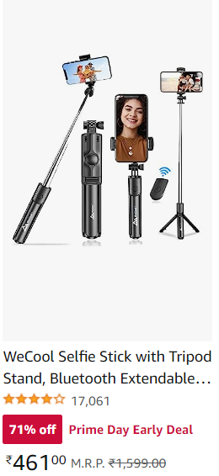 | 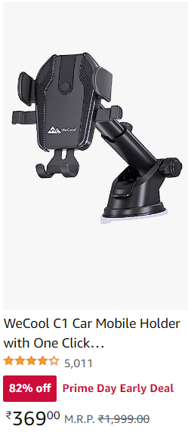 | 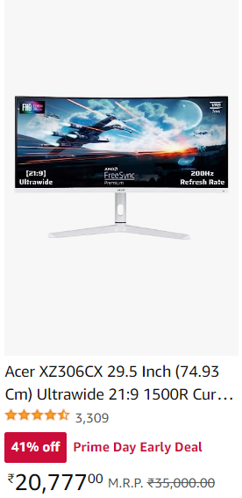
https://amzn.to/46OwfZt | https://amzn.to/3XToXjp | https://amzn.to/3De3qYV
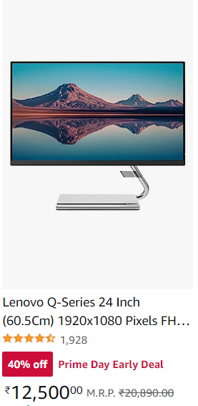 | 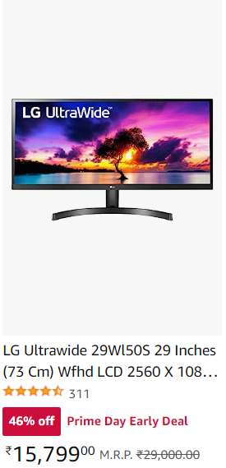 | 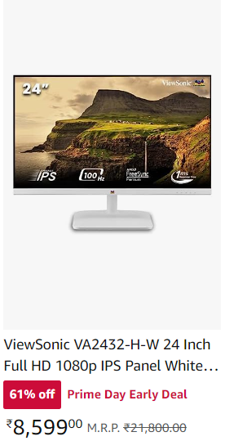
https://amzn.to/3DgtR0h | https://amzn.to/3XXUXms | https://amzn.to/3rr85nZ
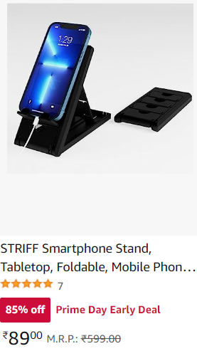 |  | 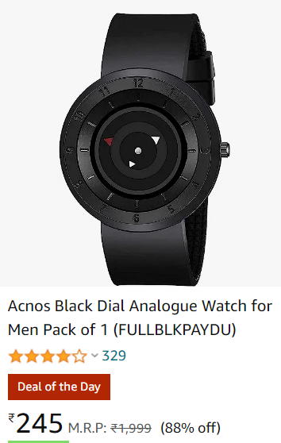  Hot
https://amzn.to/44LBvLE | https://amzn.to/3NUQaxu | https://amzn.to/3NRWrd9
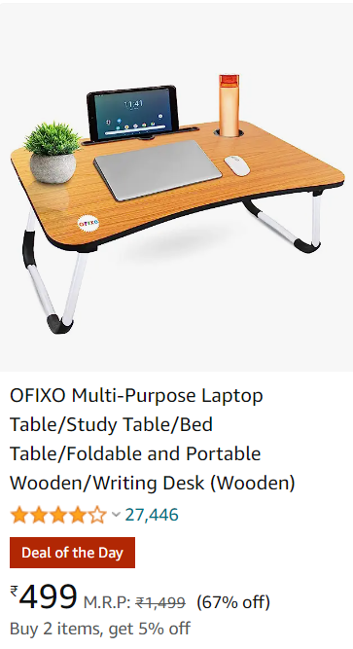 | 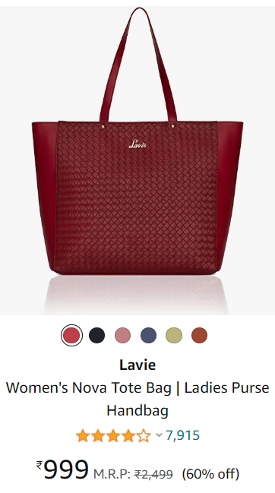 | 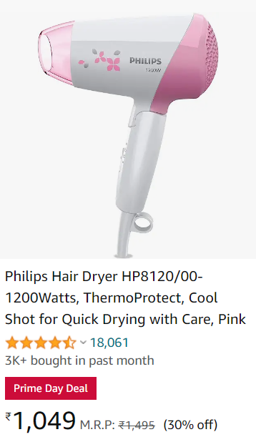
https://amzn.to/43s2tXV | https://amzn.to/3PQUu3m | https://amzn.to/3ryoM0w
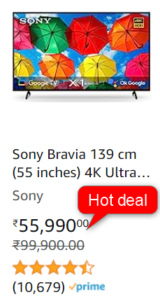 | 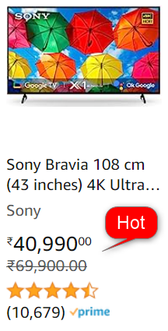 | 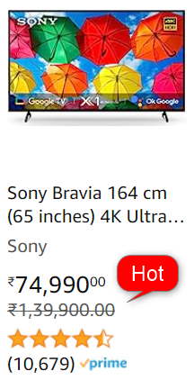
https://amzn.to/3pVVoRr | https://amzn.to/3OeSxww | https://amzn.to/44K8JLC
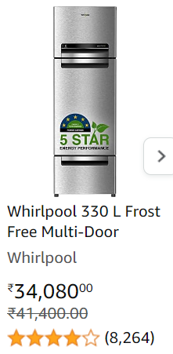 | 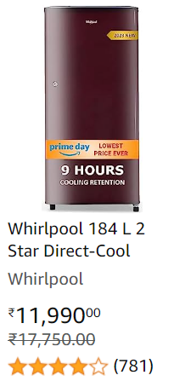 | 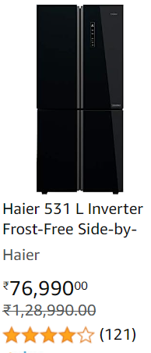
https://amzn.to/3O9ODEZ | https://amzn.to/3rvIpXd | https://amzn.to/3NRTeu7
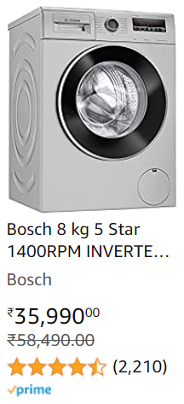 | 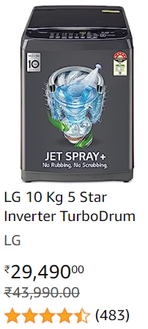 | 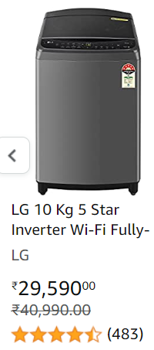
https://amzn.to/3OdPUe8 | https://amzn.to/43uJImu | https://amzn.to/3DftcfE
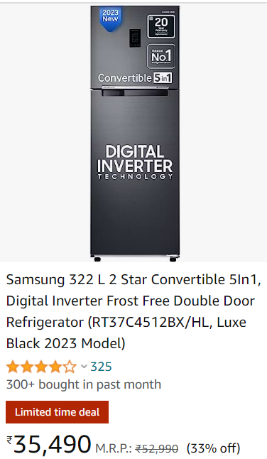 | 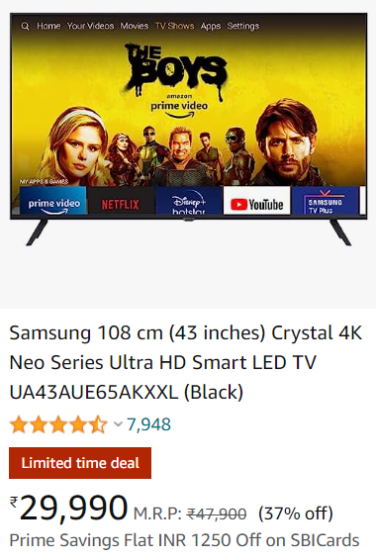  Hot | 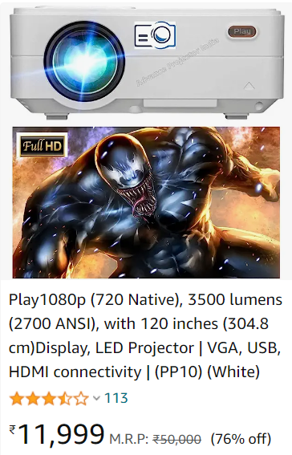
https://amzn.to/3NV0vth | https://amzn.to/3pKFyJx | https://amzn.to/44J193P
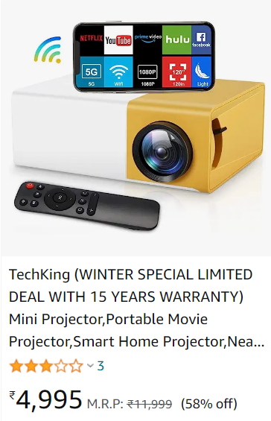 | 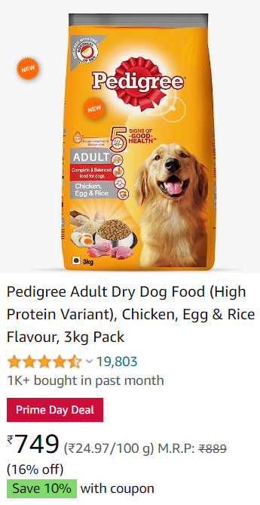 | 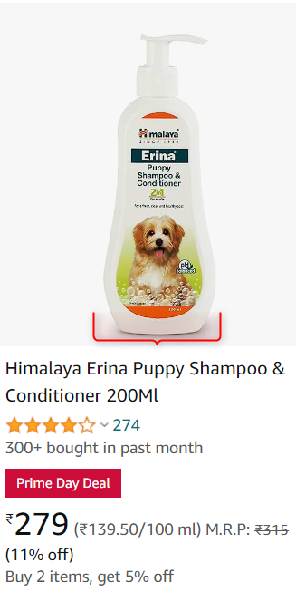
https://amzn.to/3O9Rn5f | https://amzn.to/44MJ98A | https://amzn.to/3NTYEEZ
 | 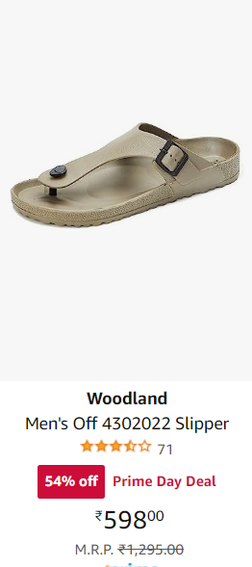 | 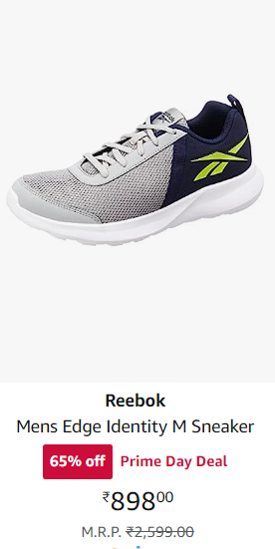
https://amzn.to/3XUyBST | https://amzn.to/3NRvXsg | https://amzn.to/46Hwx4q
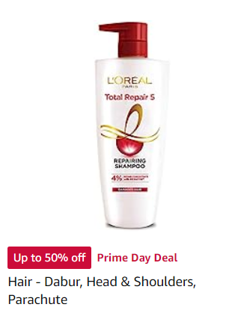 | 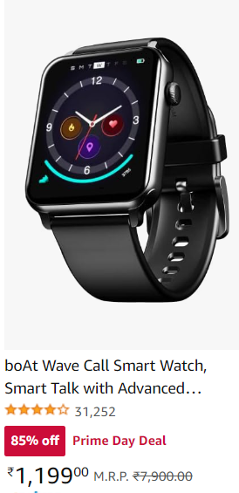 | 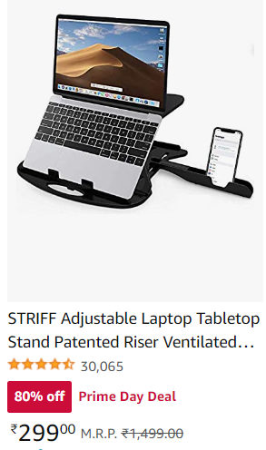
https://amzn.to/3K0D946 | https://amzn.to/3NVkIyW | https://amzn.to/471biLg
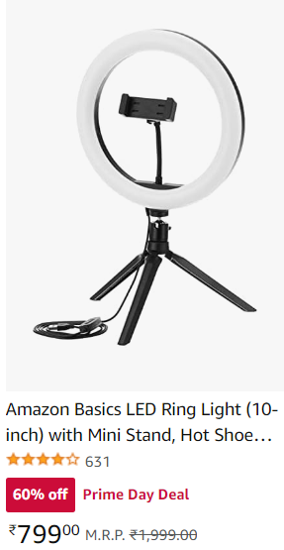 | 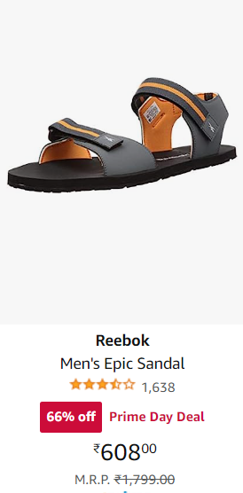 |   Hot
https://amzn.to/3Dl9i2x | https://amzn.to/3PW9LzO | https://amzn.to/3PU60uH

